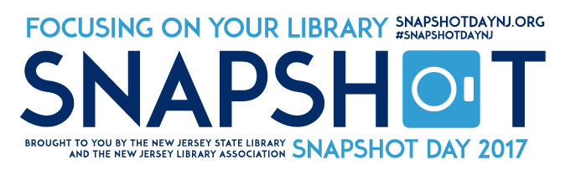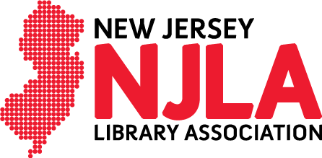

FOR IMMEDIATE RELEASE CONTACT: Emily Weisenstein
SEPTEMBER 19, 2017 emily.weisenstein@mainlib.org John Arthur
jarthur@lmxac.org

PRESS RELEASE

New Jersey Snapshot Day 2017
8th annual Snapshot Day scheduled for October 25th

Snapshot Day 2017 will be occurring at libraries across the state of New Jersey on October 25th, 2017. This event captures the impact that libraries have on their communities using statistics, photos, and stories from patrons.

We are hoping that Snapshot Day serves as a reminder to our communities of the library’s value and impact on their lives.

Members of the community and journalists can participate by taking photos of events you attend, covering events at your local library, and reaching out to your librarians to see what they have planned.

To participate tag photos, videos, and patron comments with #snapshotdaynj on any social media pages.

For more information, visit SnapshotDayNJ.org. Find promotional materials on our resources page.

###

About NJLA
Established in 1890, the NJLA is the oldest and largest library organization in New Jersey. It advocates for the advancement of library services for the residents of New Jersey, provides continuing education & networking opportunities for librarians and supports the principles of intellectual freedom & promotes access to library materials for all. Our office in Trenton, NJ provides services to over 1,700 members. For more information, go to w​ww.njla.org.​

